JSVV’S
Shri D G M Ayurvedic Medical College, Hospital & research Center Gadag
Department of KAUMARABHRITYA
Webinar on “Mutravaha srotovikaras and its treatment in children”
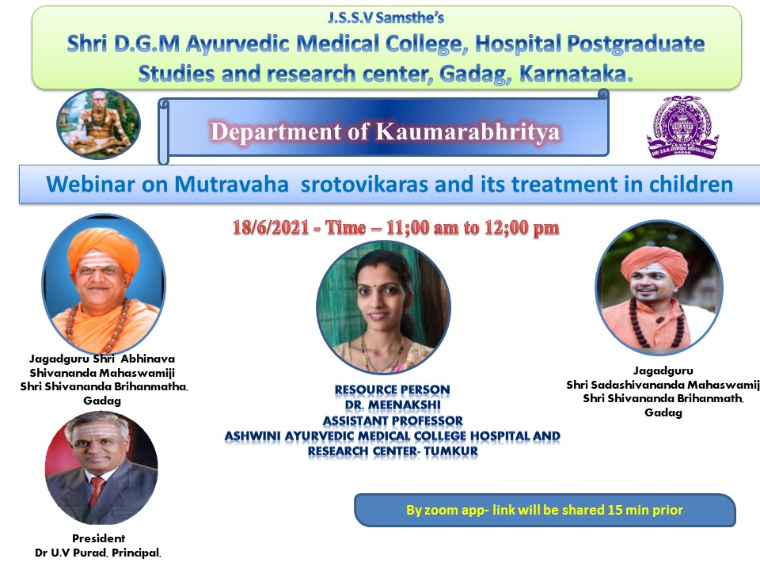

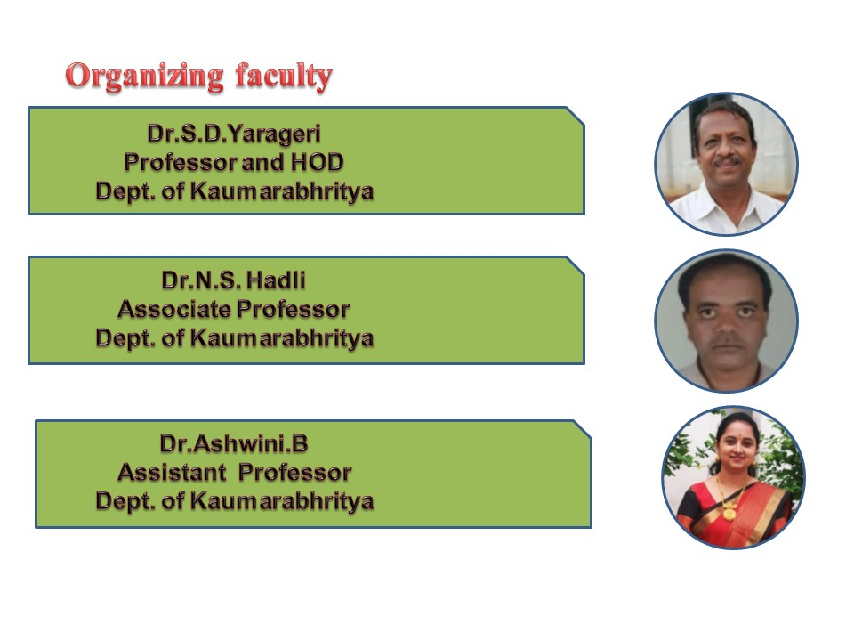

Name of the department: KAUMARABHRITYA
Date-18-06-2021 at 11am-12:30pm
Targeted Group: III BAMS, Interns, Post graduate students, Alumni, Institution
faculty
Title of the topic: “Mutravaha srotovikaras and its treatment in children”
Name of the expert resource person- Dr.Meenakshi Assistant professor,Dept. of Kaumarabhritya, Ashwini Ayurveda Medical College Tumkur
AIM and OBJECTIVES of WEBINAR
AIM:
To make students to understand about Mutravahasrotogata vikaras nidana,purva rupa rupa,samprapti, and its clinical approach.
OBJECTIVES:
At the end of this webinar each participant should be able to,
- Know, about Mutravahasrotogata vikaras that occurs in paediatrics
- Chikitsa yogas of Mutravahasrotogata vikaras
- Compose, the posology of medicines used in Mutravaha srotas vikaras.
- limitations of yogas used in Chikitsa
PROGRAM
Program Coordinator: Dr: Ashwini Kumari Assistant Professor Dept. of Kaumarabhritya DGMAMC Gadag
- Program started with lord Dhanvantari sthavana by 3rd year student Miss Pooja Siroor
- Welcome speech by Dr. Ashwini kumari Assistant professor Dept.of kaumarabhritya
- Inauguration by Principal Dr. U.V Purad. HOD Dr.S.D.yarageri and Dr.N.S.Hadli
- Presidential speech by Dr.U.V.Purad
Sir has briefed importance of Mutravaha srotogata vikaras
- Expert Resource Person Speech by Dr.Meenakshi
- Madam has elaborated basics of urinary system (Anatomy and physiology)
- She explained Mutravaha srotogata vikaras i.e(Acute glomrulo Nephritis, Nephrotic syndrome,Mootra krichra, Mutra Ashmari.
- She has highlighted differences in Mutravahasrotogata vikaras that occurs in adult and children.
- She explained Nidana,Purva rupa,Roopa,Samprapti of Mutravahasrotas vikaras.
- She explained regarding investigations and Chikitsa in Mutravahasrotas vikaras and briefed about treatment in modern medical science.
- She explained about limitations of drugs and Anubhoota yogas.
- The session was ended with vote of thanks by Dr.Ashwini kumari Assistant Professor Dept. of Kaumarabhritya DGMAMC Gadag
- All third year students and faculty members scholars, interns get benefitted by this session.
